Q1. Write a python program to add a new key-value pair to a dictionary, modify an existing value and access a specific key.
- Input: student = {"name": "Abhay", "age": 20, "grade": "B"}
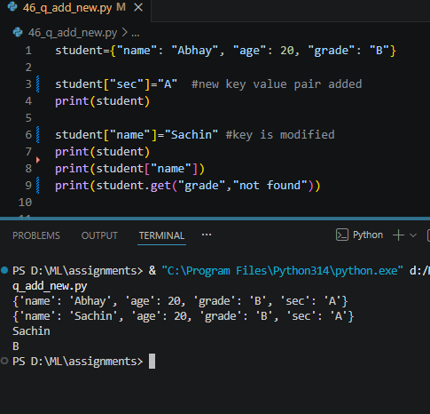
Q2. Write a python program to remove a specific key from a dictionary, retrieve all key-value pairs and check whether a given key exists.
- Input: car = {"brand": "Toyota", "model": "Camry", "year": 2022, "color": "blue"}
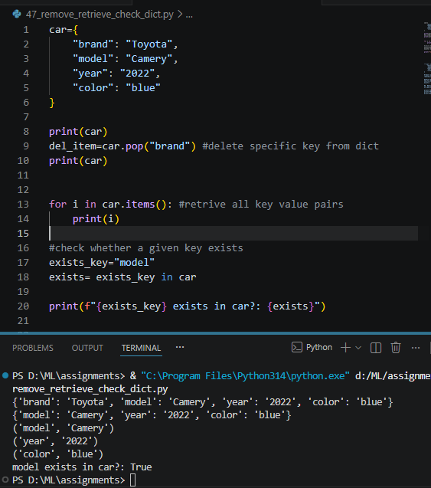
Q3. Write a python program to create a dictionary by mapping two equal-length lists, one containing keys and the other containing values.
- Input: keys = ["name", "age", "city"] and values = ["Abhay", 20, "Jharkhand"]
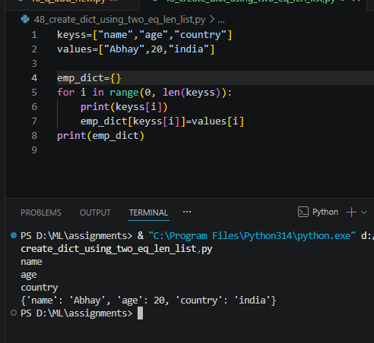
Q4. Write a python program to remove all items from a dictionary while keeping the dictionary object itself intact.
- Input: inventory = {"apples": 10, "bananas": 5, "oranges": 8}
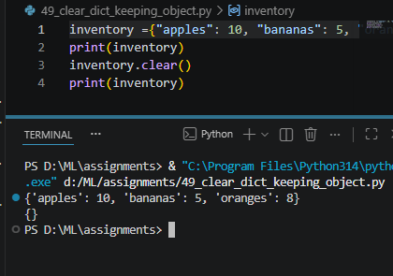
Q5. Write a python program to combine two dictionaries into a single dictionary. If both dictionaries share a key, the value from the second dictionary should take precedence.
- Input: dict1 = {"a": 1, "b": 2} and dict2 = {"b": 3, "c": 4}
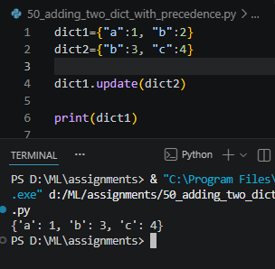
Q6. Write a python program to retrieve a specific value from a dictionary that is nested inside another dictionary.
- Input: person = {"name": "Abhay", "address": {"city": "Jharkhand", "zip": "75701"}}
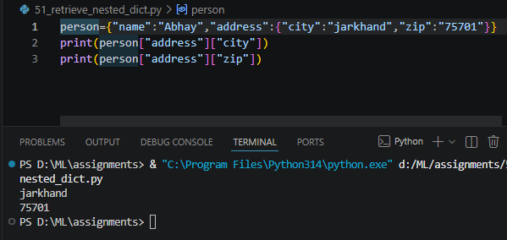
Q7. Write a python program to access the value associated with the key 'History' from a dictionary nested within the larger data structure.
- Input: student = {"name": "Abhay", "grades": {"math": 88, "Science": 92, "History": 75}}
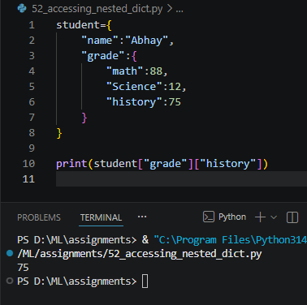
Q8. Write a python program to create a dictionary from a list of keys, assigning the same default value 0 to every key.
- Input: keys = ["math", "Science", "English", "History"] and default = 0
